ETU helps you transcend traditional boundaries and provides a travel experience that’s a perfect blend of rusticity, offbeat experience, urban Himachal, and unconventional activities that makes one a traveler, not a tourist.
Each Day a New Experience, a New Himachal (Our Itinerary)
Irrespective of the number of days you spend in Himachal, your experience is going to be simply fantastic. The best part, ‘You can Always Customize your Himachal Trip to suit your taste’. Exploring Himalayas very own Himachal just can’t get any better!
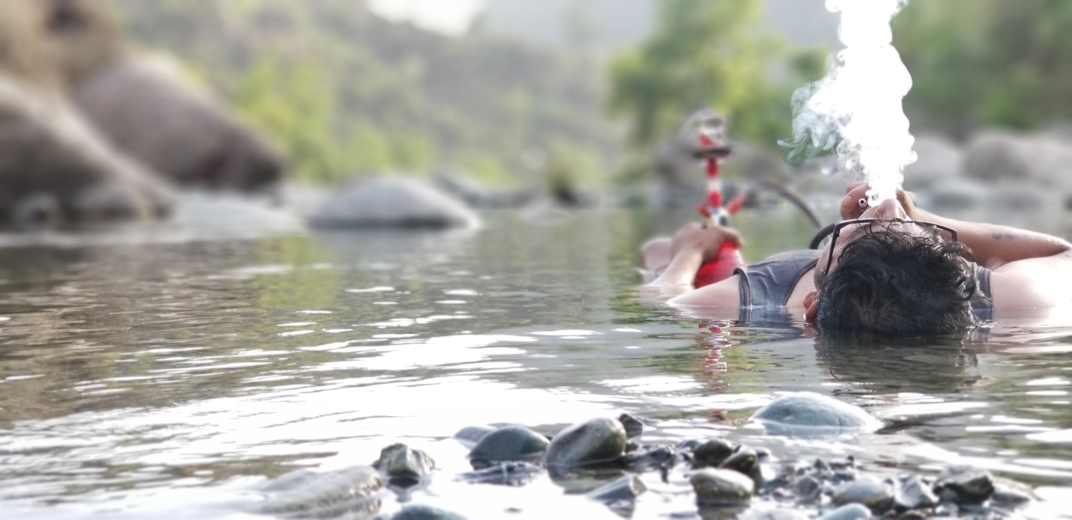

- Duration: 5 Days
- Dates: ?
- Price: ?
- Start Location: Pathankot- Bus Stop/ railway station OR Dharamshala- Airport/bus Stop/ railway station
- End Location: Same as above
- Min Group Size: 3
- Max Group Size: 14
- Places covered: Dalhousie- Chamba-Bharmour- Some Unexplored places
- Age criteria- 15 to 55 year old
- Style: Open

Arrival and Departure tip: This trip starts from Pathankot Railway Station or Bus Stop. Most of the Buses and trains reach early in the morning. If you are planning to take a Flight then the nearest airports will be in Dharamshala and Jammu (Distance from Jammu and Dharmshala is 2.5 hrs from ETU)
If you need any help in flight/train/bus bookings, feel free to reach out to us and our team will be happy to suggest you the best flight/bus/train options.

Brief Itinerary:

Day 1: Arrive in Pathankot- Local Places near Dalhousie, ETU Homestay- Bonfire-BBQ- Live Music/karaoke
Day 2: Dalhousie- Jot- Khajjiar
Day 3: Bharmour- Hike- temples- camping
Day 4: Hadsar- kugti- Hike- camping
Day 5: Riverside-cooking- fishing- ETU homestay
Day6: Drop Off

Detailed Itinerary
Day 1 (Pick up in Pathankot/ Jammu/ Dharmshala)
The Rustic/Rural Himachal
Arrive at Pathankot before 9 am. A cab will pick up all the travelers and take you to ETUs homestay. The beauty of Himachal exists in its landscape and that’s comparable to none. On the way to our destination we will explore waterfalls, the mighty ever flowing rivers, gigantic dams, temples that are an architectural delight and the valleys that holds nature’s beauty in its purest form!
Start our trip with a visit to the renowned ‘Mukteshwar Temple’. This temple stands tall at the hill top and is a landmark around the city. Carved out of a hill during the time of Mahabharata, the temple and surrounding caves are an architectural delight. After spending some time here we will head towards Ranjit Sagar Dam. This dam is the largest hydroelectric dam in the state of Punjab/Himachal Pradesh.
Post visiting Ranjit Sagar Dam we will go to one of the most beautiful and unexplored places called ‘Anan Waterfall’. The temple is located right next to a gorgeous hundred feet high waterfall.

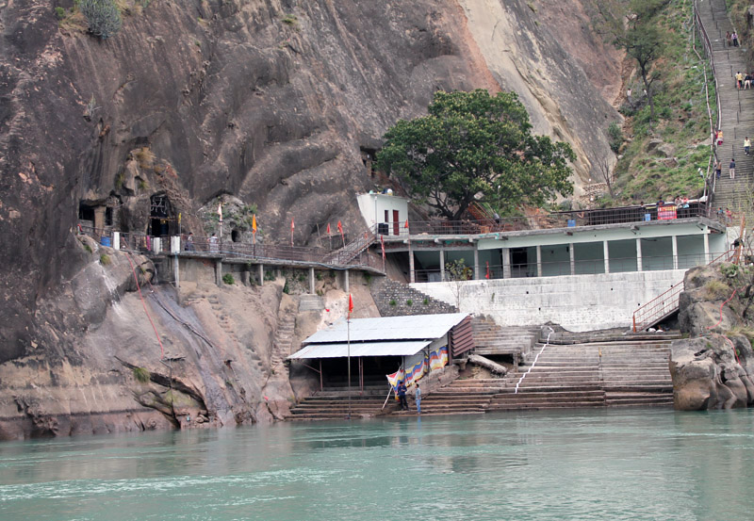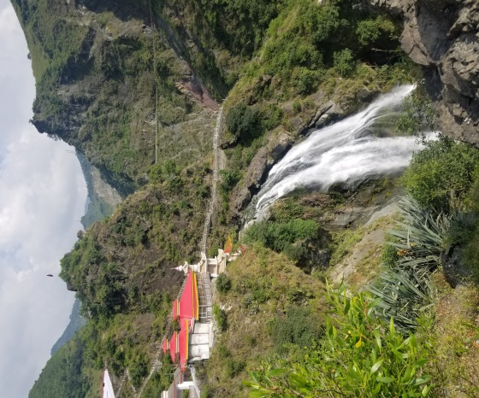

After reaching ETU, guests can take a rest, freshen up and order food according to your mood since ETU has its own Home grown restaurant - Anaj
ETU is set amidst picturesque location. The homestay is surrounded by jungle and close to ‘Hamachli Village’ will provide you an authentic Himachal experience.
ETU’s Homestay is different and meant for those who don’t just want to stay but Live Life Himachali Style!
- Huts inside the ETU’s Homestay!
- Rooms
- Multiple Tents for that Outdoor Experience!
- Several Camping Spots, because Mountains are the best place to camp!
- Dedicated Bonfire Place at multiple spots

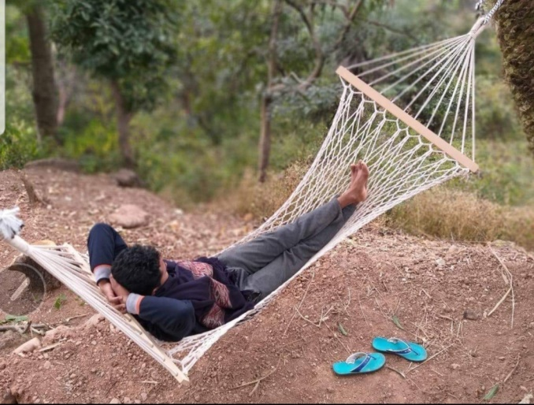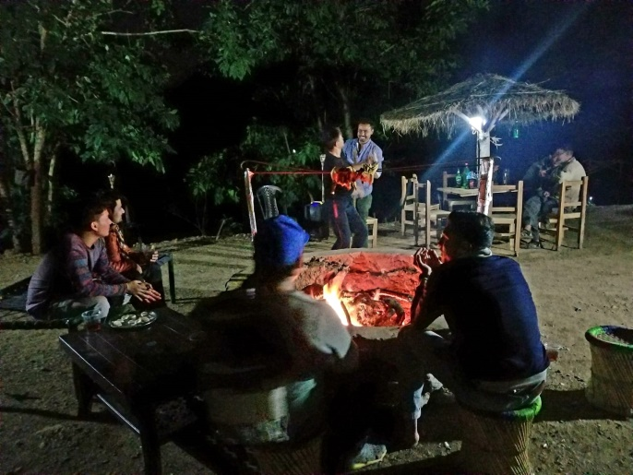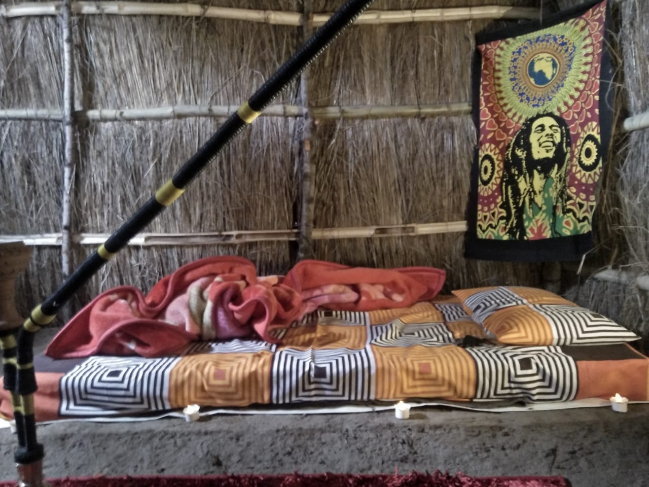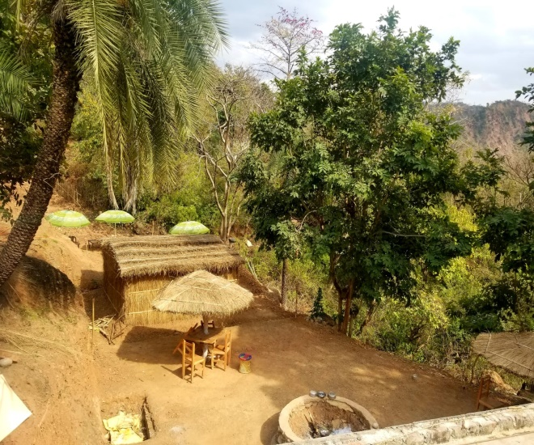

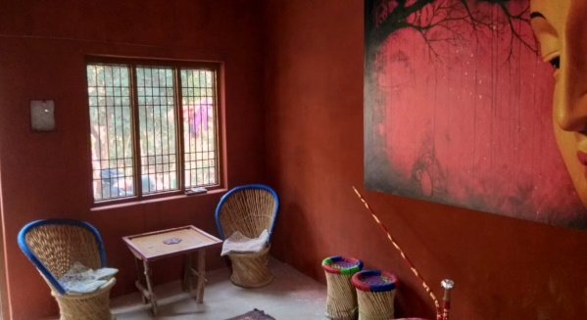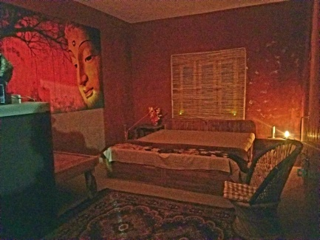
At ETU Homestay we will organize several fun games, both indoor and outdoor, we will also cook some delicious meal in most primitive way! Yes, we will use wood as fuel and stove made up of clay. And yes, not to forget the clay utensils which adds distinct flavor to the food! Also, arrangements will be made for bonfire, delicious BBQ.
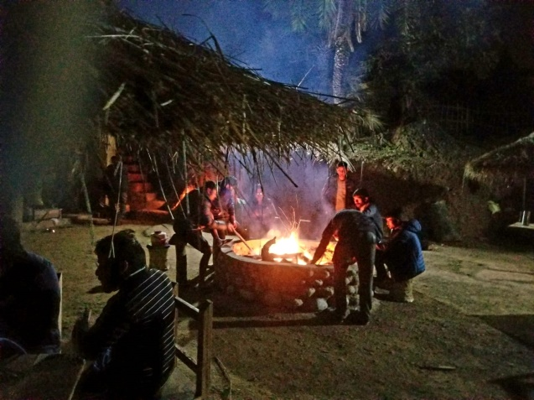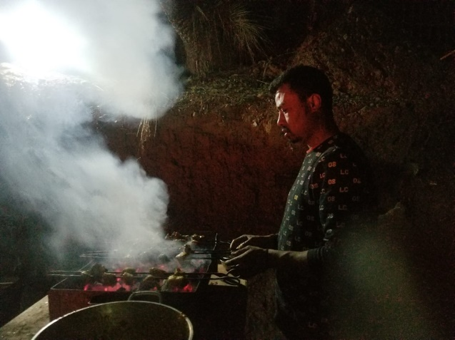
Day 2
The Lively Himachal
After breakfast we will head to Dalhousie and
On the way we will stop at Jot. You will be happy to know that the acclaimed Indian movie - 'Gadar' was shot in Jot!
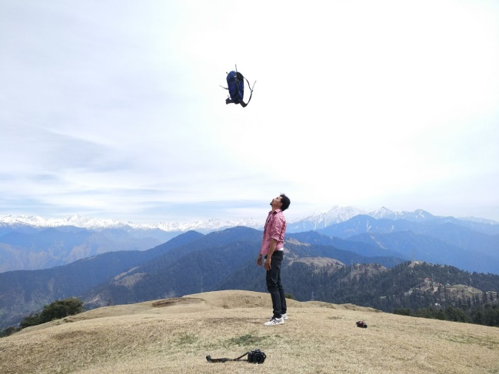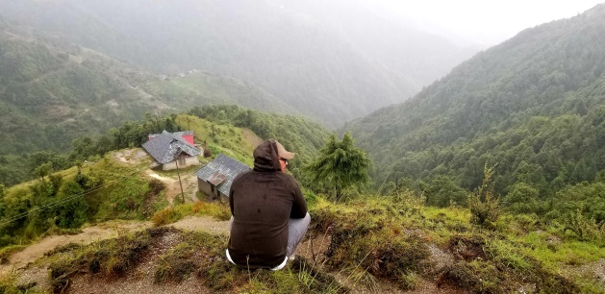

Around noon we will reach Khajjiar which is a hill station 20 kms north of Dalhousie. It is also called as the mini Switzerland as it is located 6500 ft. above sea level and is surrounded by meadows, forests, and mountains. We will have lunch in Khajjiar and you can also indulge in the following activities:
✓ Boating
✓ Zorbing
✓ Paragliding
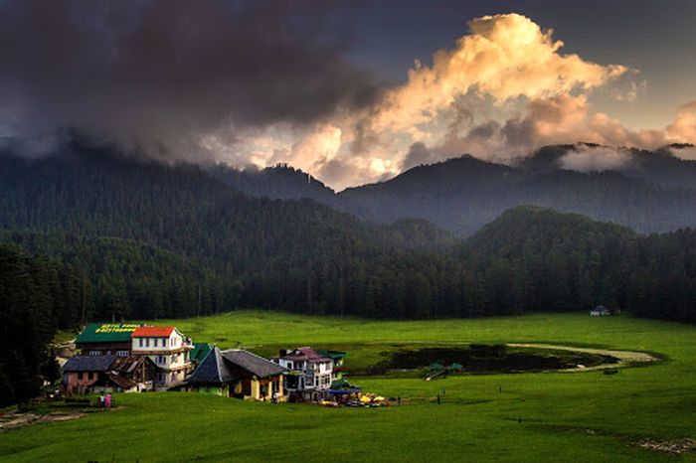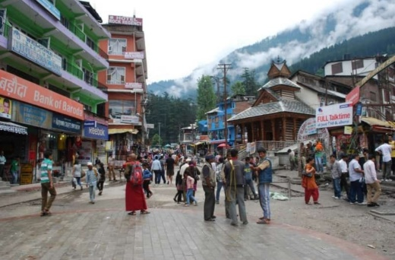

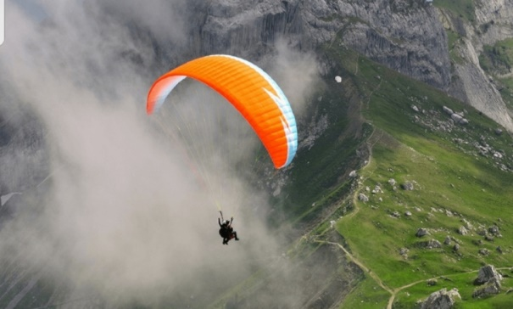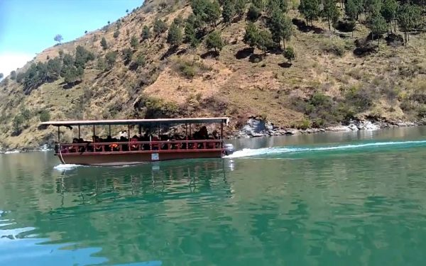

After Exploring Dalhousie our next adventurous destination is Bharmour
The drive to Bharmour is quite adventurous and you are bound to be mesmerized with the amazing panoramic view this route offers. Our night stop will be at a guest house in bharmour.
Bharmour- Set amidst the magnificent snow clad hills of Dhauladhar and Shivalik, Bharmour is regarded as the land of Shiva, a Hindu god. The place is blessed with virgin beauty untouched by masses. Bharmour tourism has grown significantly because of people's interest in ancient temples, wildlife sanctuaries, waterfalls and snow covered mountains. Bharmour is often referred as the land of Shiva because of belief that lord Shiva resides at manimahesh which is located in this area. Bharmour is popular for its natural beauty of snow covered mountains, for very old archaeological remains, primarily the temples and Manimahesh .
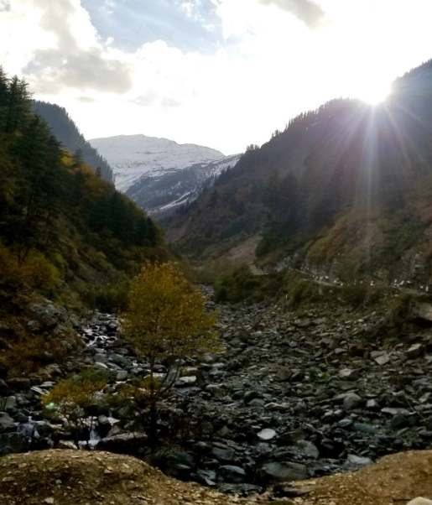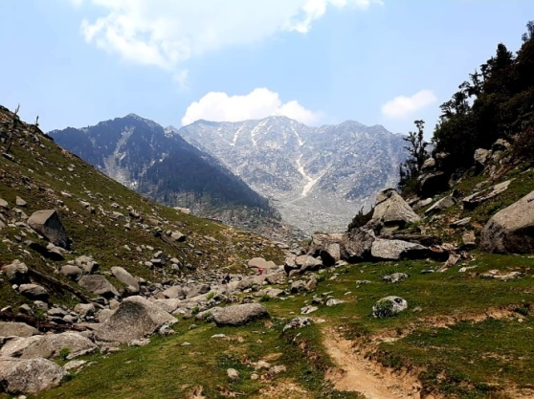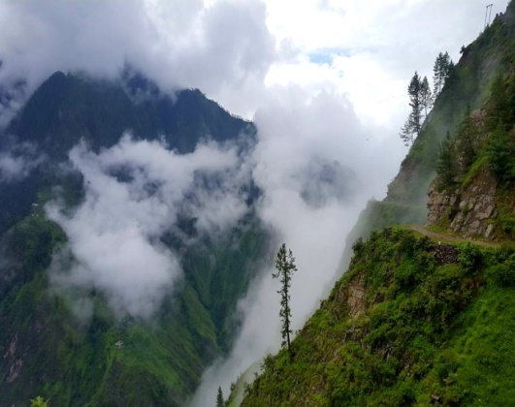
Day 3
The Exotic Himachal
After an early morning breakfast we will head to Bharmani Mata temple for a trek . The trail leads you past the Churasi Mata mandir and through the gaddi villages, and apple orchards with snow peaks of Pir Panjal in the backdrop. The Temple is located at the top of the hill, surrounded by snow.

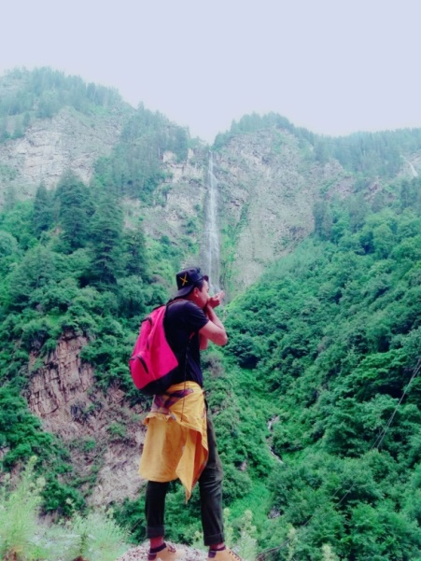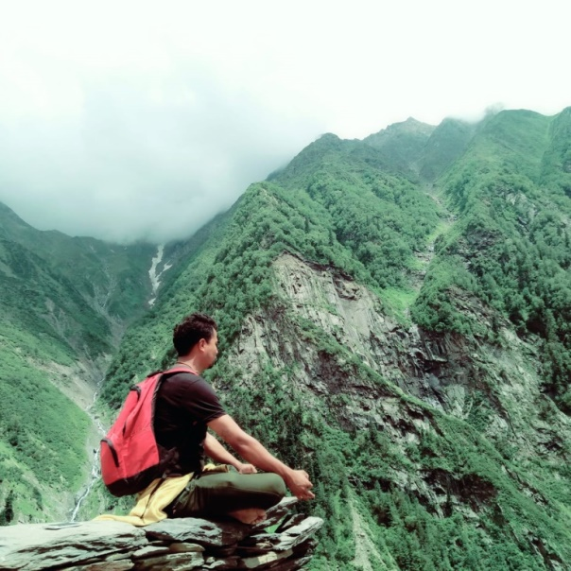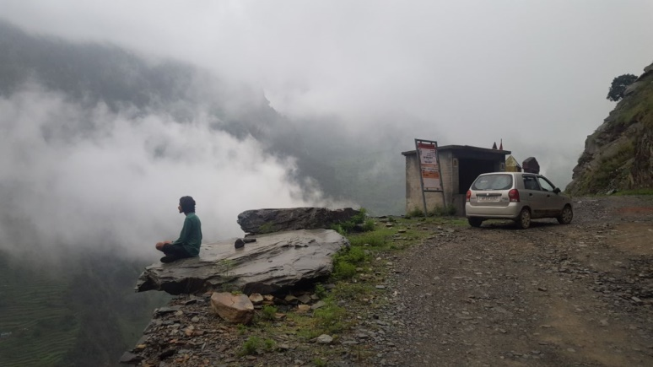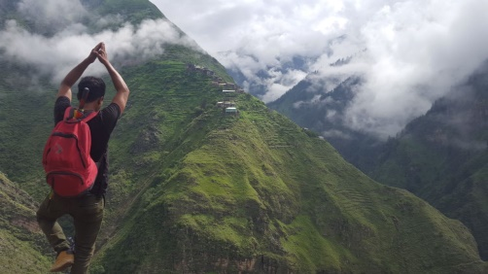
After the trek we will head to Hadsar. Hadsar is Hadsar, a picturesque spot from where the trek of 14km to Manimahesh Lake commences (not included- Different package for Manimahesh ).
Once we are in hadsar we will visit Hadsar Waterfall. Hadsar waterfall is one of the biggest waterfalls in height.

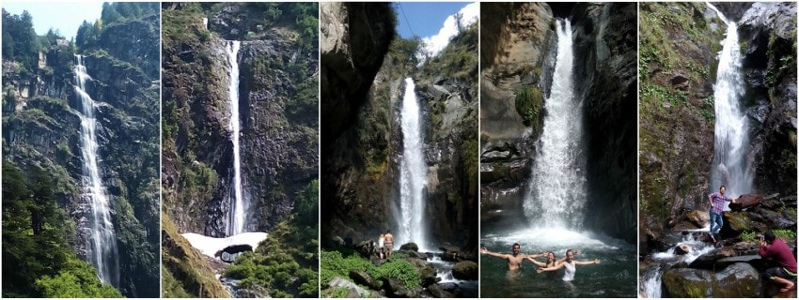
In the evening we will visit or camping place in Kugti and enjoy the nigh with bonfire, BBQ and local cuisines.
Day 4:
Adventurous Himachal
After a hearty breakfast at the campsite we will head towards toward our next hike in Kugti. Kugti village happens to be the last inhabited village in the picturesque valley
Our trek will be till Kartikeya Mandir is also known as Keylong (also spelled as Kelang).
Swami Kartikeya Temple comes under Kugti wildlife sanctuary area hence visiting this temple gives you an immense satisfaction not only because of the temple but also because of the amazing ambience of green mountains, waterfalls and wild animals. In the evening we will head back to our camp sight

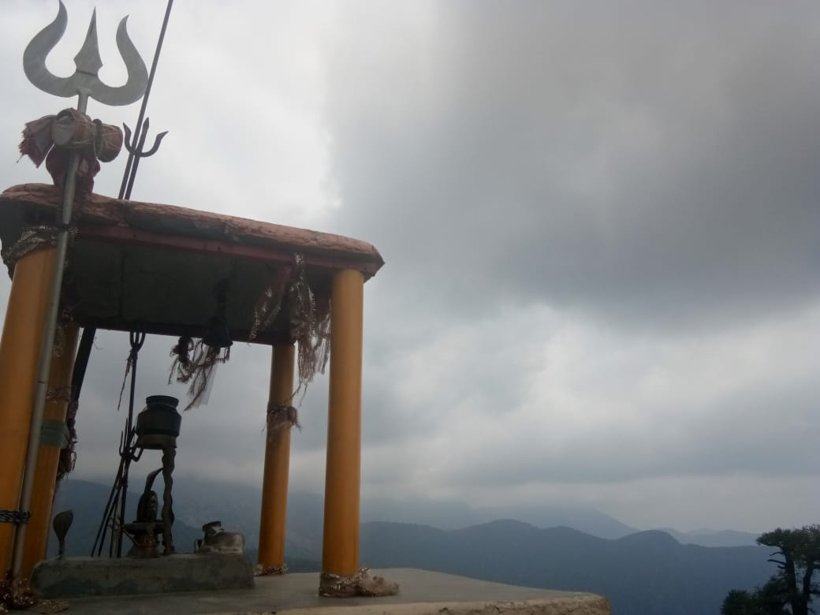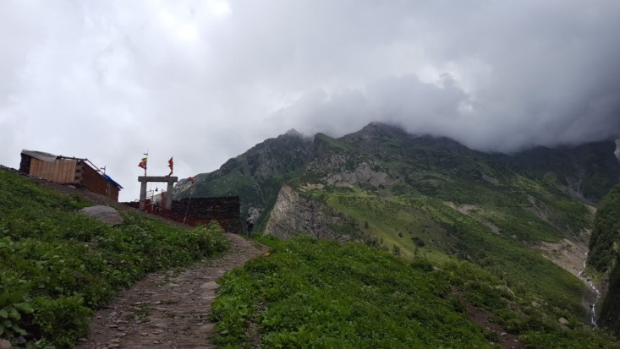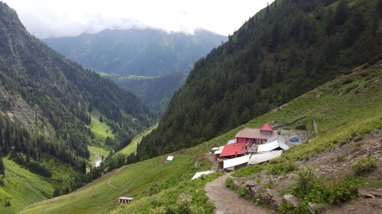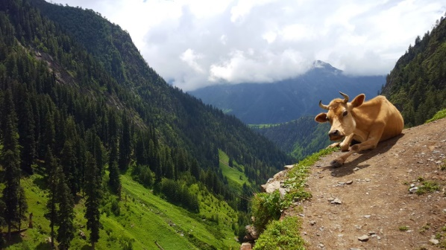

Day 5
The Riverside Himachal
After an early morning tea we will head back to ETU homestay.
On our way back from Bharmour we will make a halt at a riverside which is next to ETU homestay for Lunch. This will be a very relaxing and a calming experience. You can enjoy many unconventional activities like Meditation, relax in the floating beds, calm rafting, and bathing in fresh water while our in-house cook prepares lip smacking delicacies!
Have you ever experienced full body mud pack? If not, you can definitely try it on this day. It’s not just refreshing but is also known to have certain therapeutic properties.
Also, have you ever taken a swim in river’s safe spots and what about fishing, as well as cooking the fish you caught by the river side?

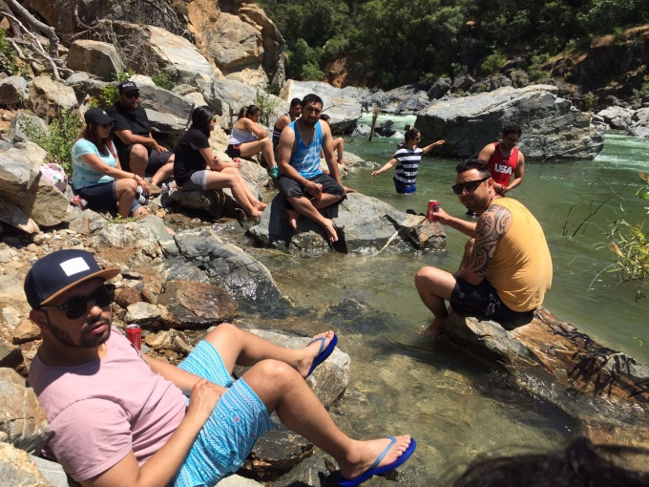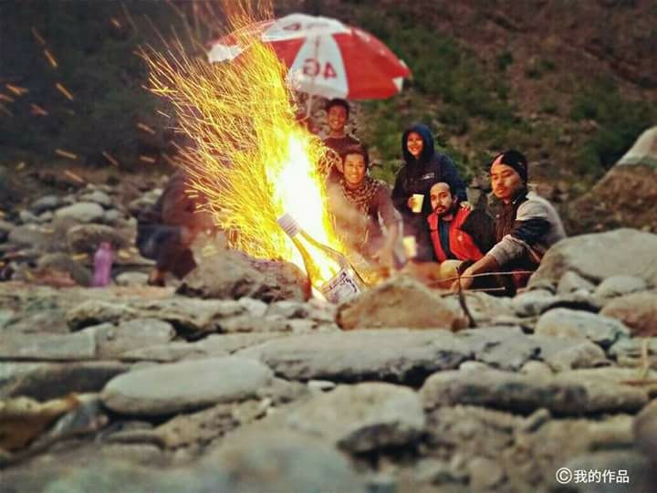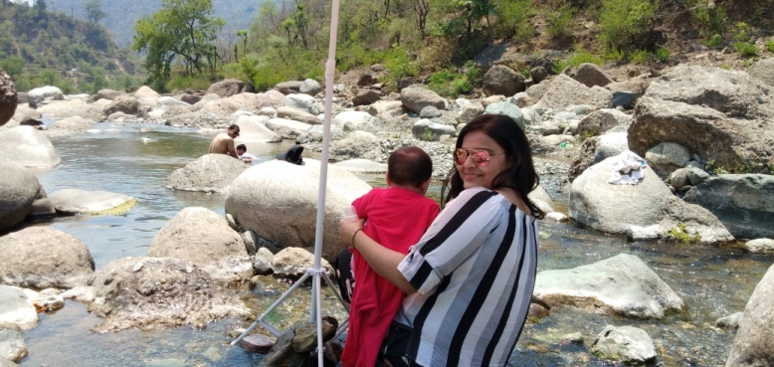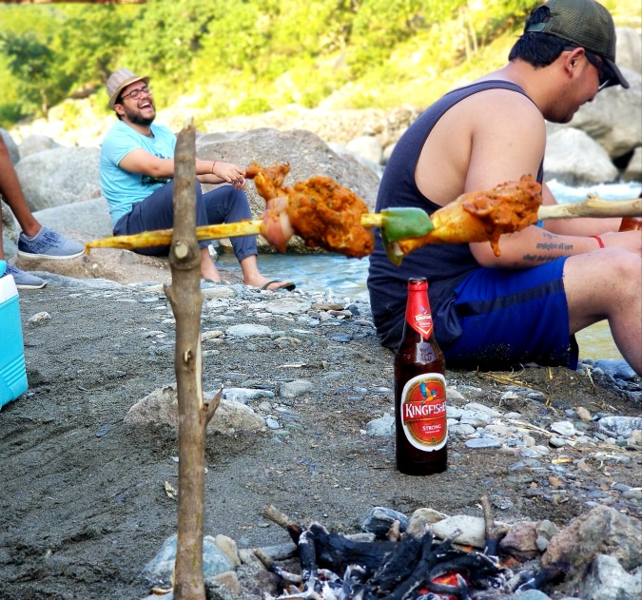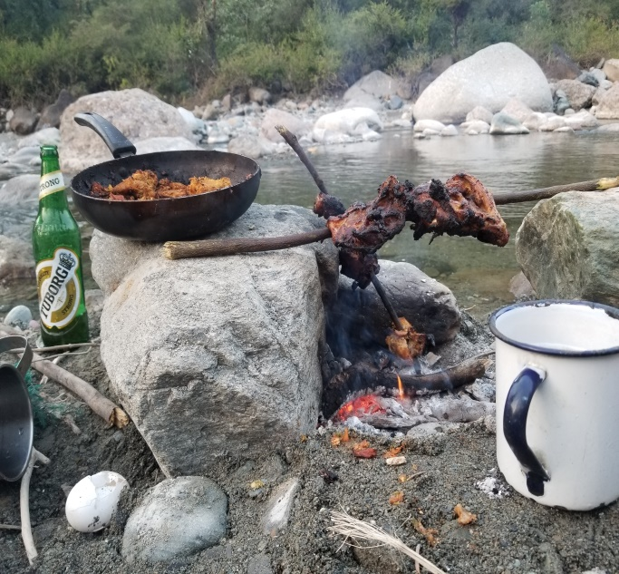
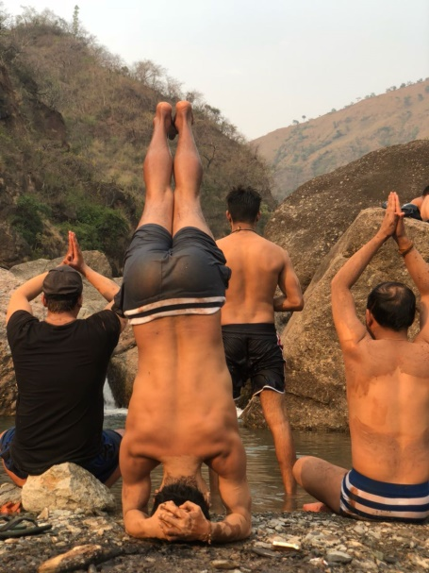
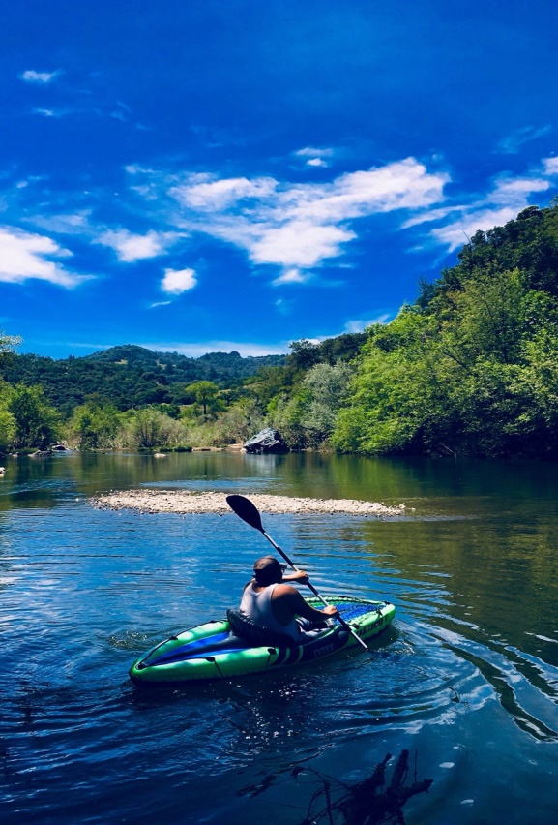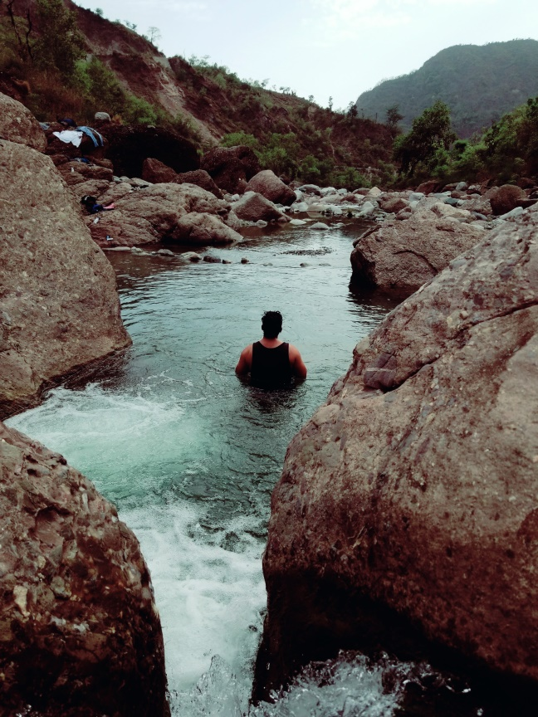
When you are outside ETU’s Homestay you can do the following:
- Hike to places nearby, they are meant to be perfect for everyone and these won’t tire you much.
- Fish in the river as well as cook them by the riverside!
- Safely relax in river using water tubes.
- A perfect picnic by the river side including live cooking, camping, yoga, meditation, swimming, and some fun activities all day long!
- You can also request for an outdoor camping amidst nature.

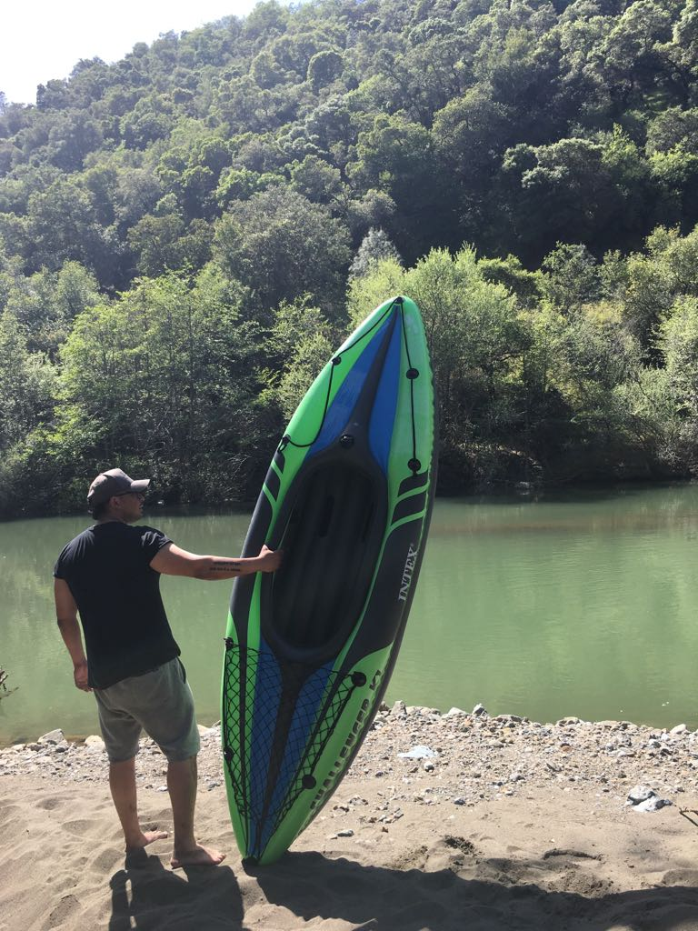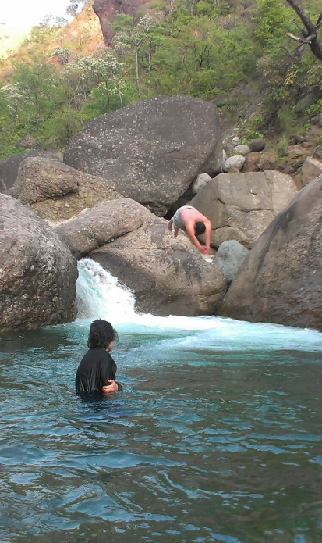

Note
Let us know your requirement and we will provide you a Customized Experience that suits your needs.
Contact Us
Website – www.ETUadventures.com
Email – admin@etuadventures.com
Phone –9882121616/9354712613/ +14088937953(US)
Physical Level: While the tour itself is not very strenuous, please note that it can involve the following: somewhat long days, a good amount of walking, early morning wake-ups and other similarly challenging scenarios.

Subject to Change: Please keep in mind that the above itinerary and activities are subject to change. Travel sometimes involves unexpected situations so things might need to be re-arranged at times. However, it is important to remember that travel is all about the journey, and so even the unexpected situations we may face should be treated as part of the overall experience!

Accommodations: Prices are based on the sharing of rooms and single members of the group will typically be put together. While we do our best to secure as many rooms with separate beds as possible, sometimes two members of the group might have to share a large bed but that’s all part of the adventure and we guarantee we’ll have a blast anyway.

Pick Up and Drop off: Please note there are no individual pick up and drops. Your Airport/Railway station/Bus station transfers will be clubbed with other roamers travelling with you on this trip. This might result in some wait at the Airport/Railway station/Bus station while pickup and an early drop at the Airport/Railway station/Bus station while leaving. If you want an individual pickup, let us know and we will arrange a private taxi for you. Price for that will be on the actual basis and you can pay the amount directly to the driver.

Terms and conditions:
We will not be liable for any claims or expenses arising from circumstances beyond our control such as accidents, injuries, delayed or cancelled flights & acts or forces of nature. The participants will have to bear the charges of cancellation (if charged by the hotel & other suppliers) arising due to delayed or cancelled flights/trains & acts or forces of nature.

Cancellation policy:
- 75% of your booking amount will be refunded if you cancel your participation before 45 days of the tour date.
- 50% of your booking amount will be refunded if you cancel your participation before 30 days of the tour date.
- 25% of your booking amount will be refunded if you cancel your participation before 15 days of the tour date.
No refund afterwards.
Breakfast will be complimentary throughout the Journey.
Package Cost does not Include:
- Air ticket, train ticket, bus ticket or any other transportation fare.
- Entrance fees, Camera fees, Guide fees or any other fee levied by authority.
- Personal expenses including shopping, tipping, charges for availing additional facility at the hotel/cottage like laundry.
- Meals and drinks pricing apart from the ones mentioned above.
- Insurance charges, evacuation in case of mishaps.
- Pricing for additional activities like horse riding, complete list mentioned below.

Activities (To be paid separately, activity rates/pricing not part of package pricing)
- Hiking
- Camping
- Boating
- Horse Riding
- Zorbing
- Paragliding
- Yoga
- Meditation
- Swimming
- Cycling
About this Package:
- On all 3 days there will be different Terrain Sightseeing which will include Mountains, River, Forest, Jungle and Waterfall.
- 24*7 Customer Support.
- Cottages and Hotels used during this trip will offer you a beautiful and memorable experience. They are located on different terrains. Being away from city you will be able to experience pristine nature perfectly.

We welcome you to Himachal Pradesh, the land of Himalayas, adventure and pristine nature!

