ETU helps you transcend traditional boundaries and provides a travel experience that’s a perfect blend of rusticity, offbeat experience, urban Himachal, and unconventional activities that makes one a traveler, not a tourist.
Each Day a New Experience, a New Himachal (Our Itinerary)
Irrespective of the number of days you spend in Himachal, your experience is going to be simply fantastic. The best part, ‘You can Always Customize your Himachal Trip to suit your taste’. Exploring Himalayas very own Himachal just can’t get any better!
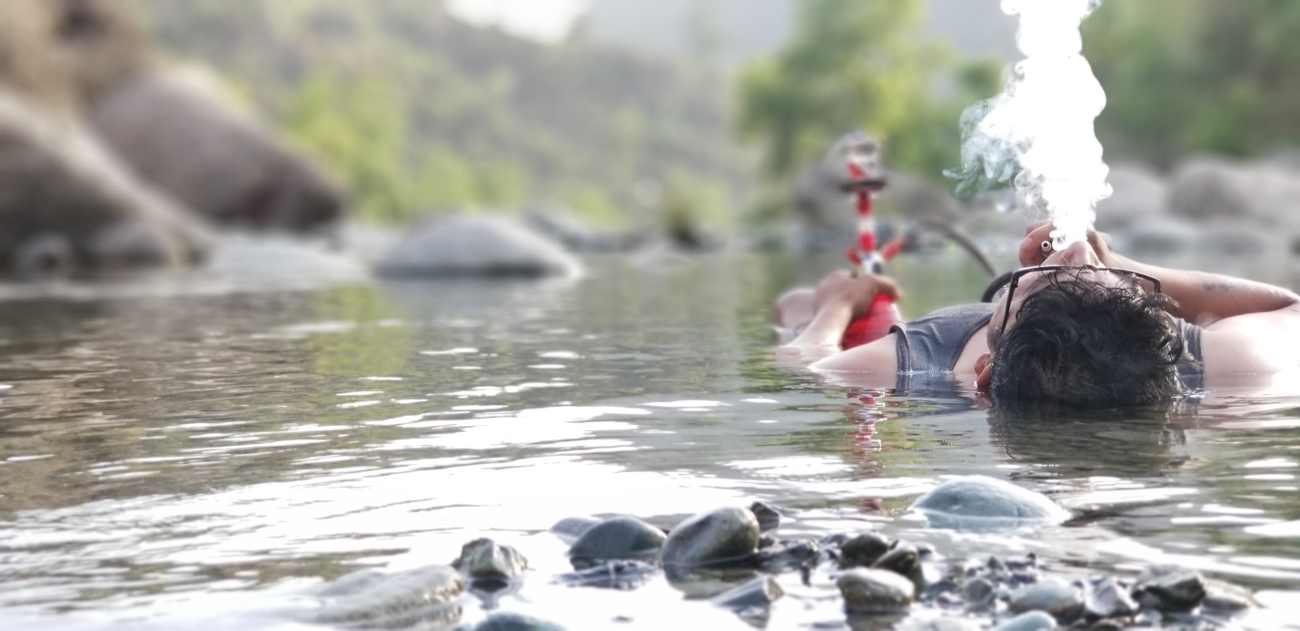

- Duration: 3 Days
- Dates: NA
- Price: NA
- Start Location: Pathankot railway station
- End Location: Same as above
- Min Group Size: 2
- Max Group Size: 14
- Places covered: Chamba – Dalhosuie- Jot- Dharmshala-Mcloadgunj- Kangra
- Age criteria- 15 to 55 year old
- Style: Open

Brief Itinerary:

Day 1: Arrive in Pathankot- Dalhousie, Khajjiar , Unexplored places
Day 2: Hike/Trek (Dainkund- Jot), ETU Homestay- Bonfire-BBQ- Live Music/karaoke
Day 3: Riverside- Swimming, fishing, Kayaking , Live cooking
Day 4: Drop Off
Package Cost Includes:
- Pickup and Drop Off from the nearest Airport/Bus Stand/Railway Station.
- Food Plan
- Guide
- Free Transportation for the whole trip

Food Plan:
Complimentary Break Fast

Day 1 (Pick Up from Pathankot Railway station.)
The Lively and Exotic Himachal
As the name suggests, this day is meant to explore the exotic locations of Himachal Pradesh. The beauty of Himachal exists in its landscape that’s comparable to none, and its waterfalls, the mighty ever flowing rivers, gigantic dams, temples that are architectural delight and the valleys that hold nature’s truest beauty in its purest form!

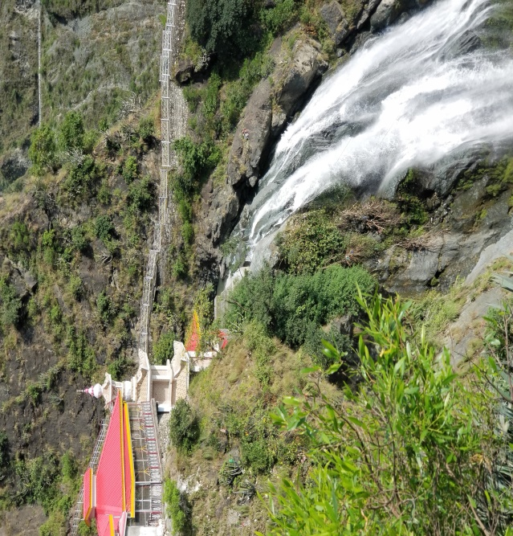
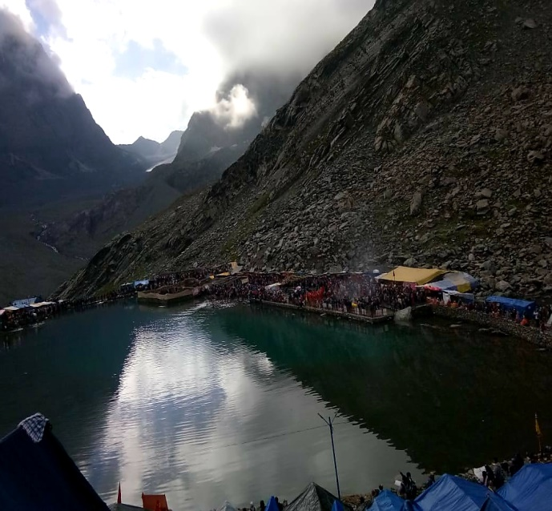
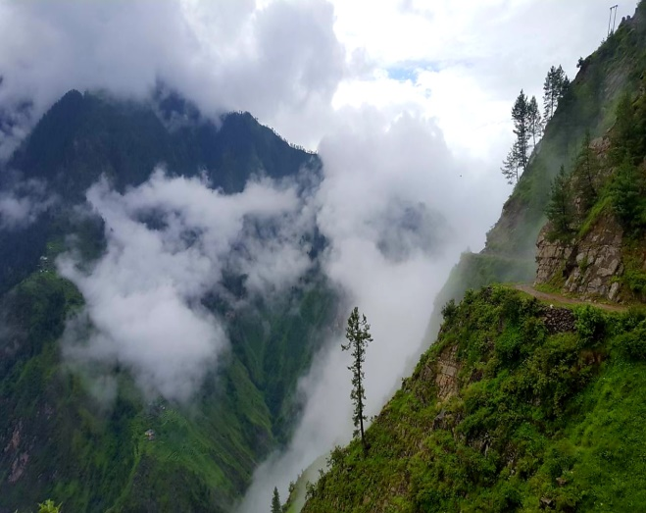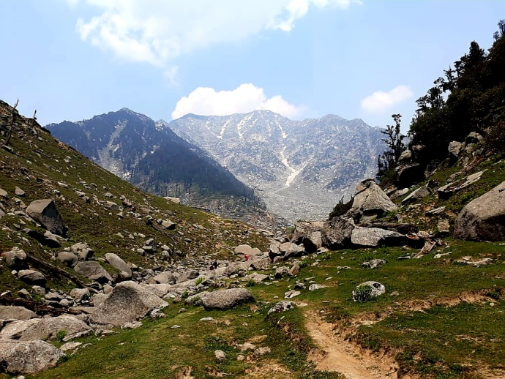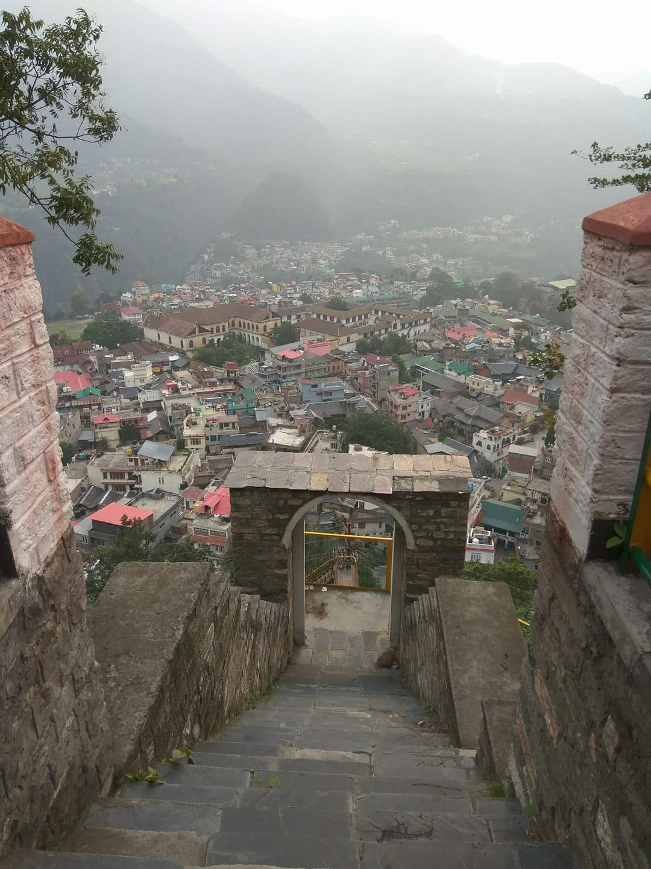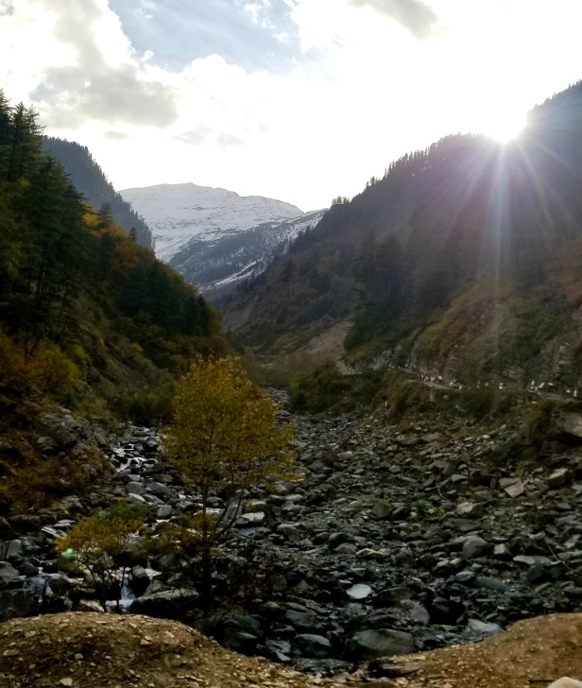

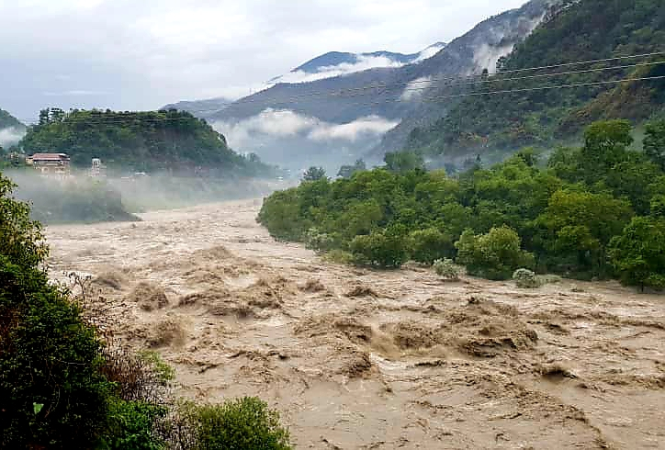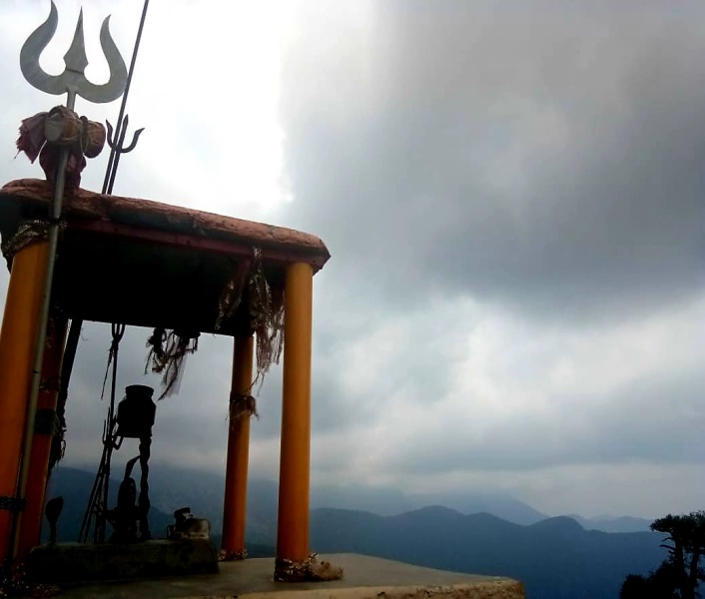
Start our trip with a visit to the renowned ‘Mukteshwar Temple’. This temple stands tall at the hill top and is a landmark around the city. Carved out of a hill during the time of Mahabharata, the temple and surrounding caves are an architectural delight. After spending some time here we will head towards Ranjit Sagar Dam. This dam is the largest hydroelectric dam in the state of Punjab/Himachal Pradesh.
Post visiting Ranjit Sagar Dam we will go to one of the most beautiful and unexplored places called ‘Anan Waterfall’. The temple is located right next to a gorgeous hundred feet high waterfall. (https://www.tripoto.com/trip/there-are-no-shortcuts-to-any-place-worth-going-5bbc76872bde8)
We will check in around noon at Arpana or Forest Department resort/Guest House in Dalhousie.
After Lunch we will go to Khajjiar which is also referred as mini Switzerland as it is located 6500 ft. above sea level and is surrounded by meadows, forests, and mountains. Later in the evening we will head back to Dalhousie. Dalhousie offers an excellent ambience to relax and spend time with family and friends. And Yes, you can indulge in Shopping too!

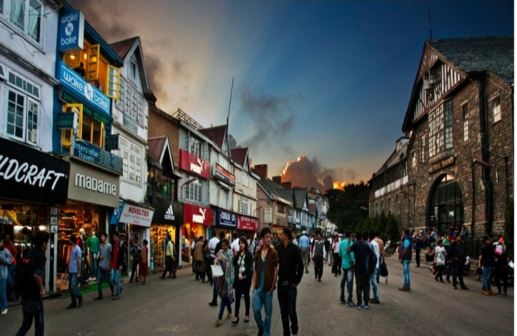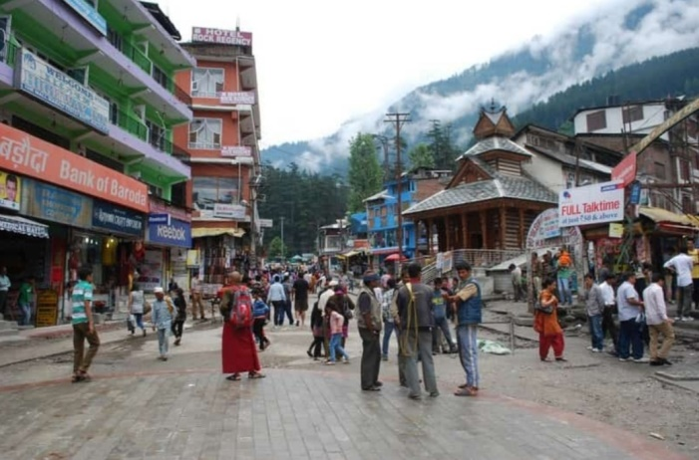
Some of the activities you could in these places are
- Horse Riding
- Zorbing
- Paragliding
- Yoga
- Meditation

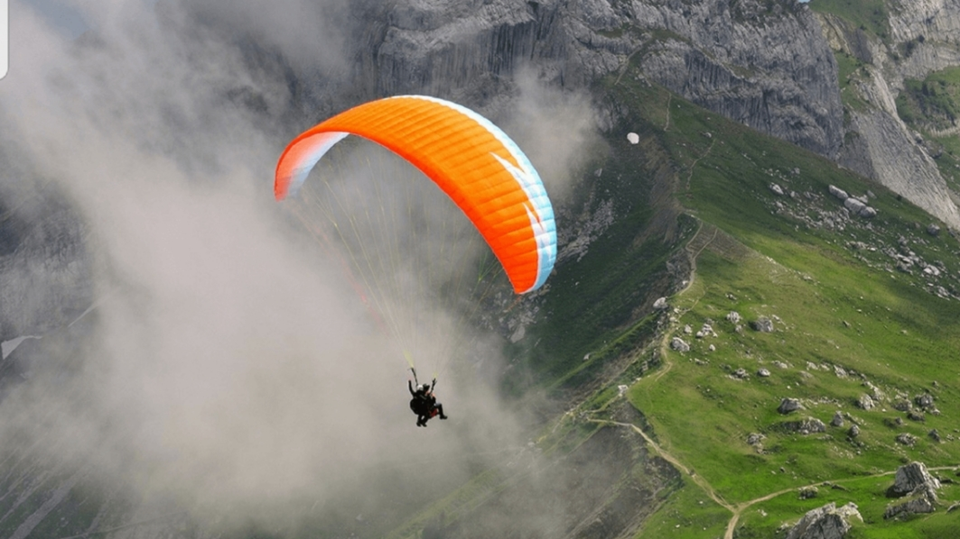

Day 2
The Adventurous and Rustic/Rural Himachal
A fun-filled day involving trekking. After having breakfast we will head to Dainkund to start our trek. No trail around Dalhousie and Khajjiar affords such majestic views of the Himalayas throughout the journey. Jot and Dainkund are linked via a 7 kilometre ridge that undulates between an elevation of 2450 and 2750 metres above sea level. Walking along this ridge provides unparalleled views of Pir Panjal and the Middle Himalayas. This trek (moderate) will approximately take around 5 to 6 hours to complete. Once you are in Jot our driver will pick you and take you to ETU homestay for the evening.
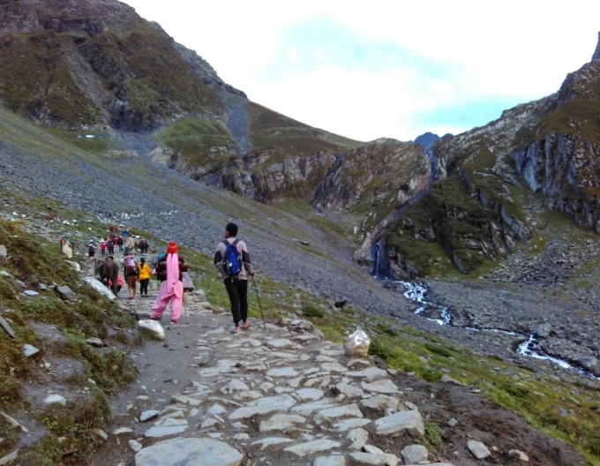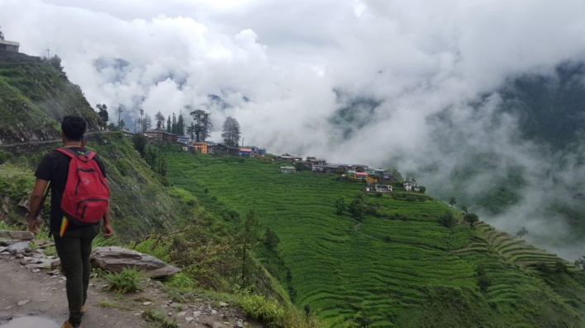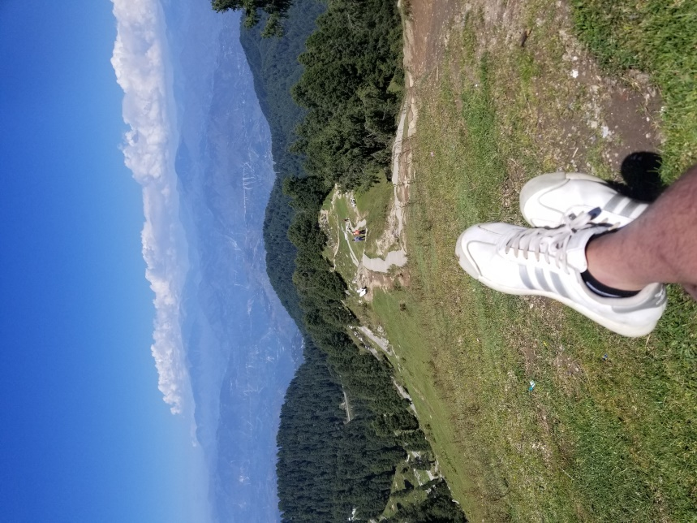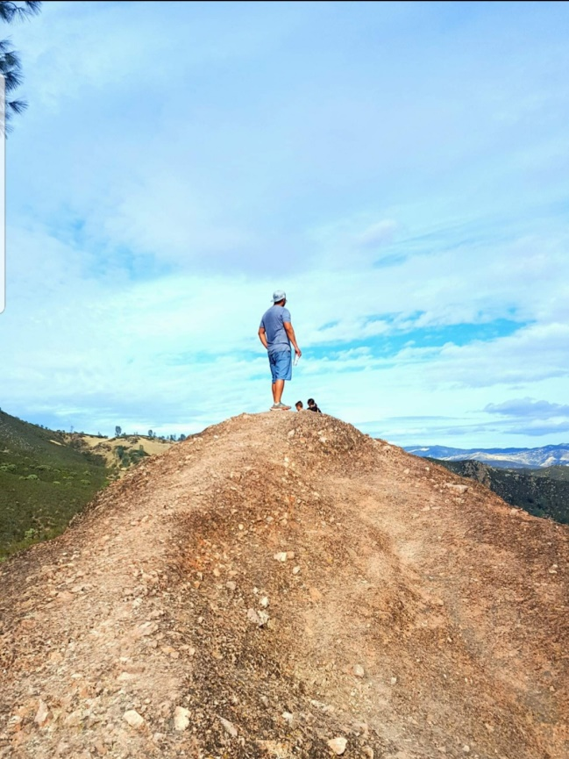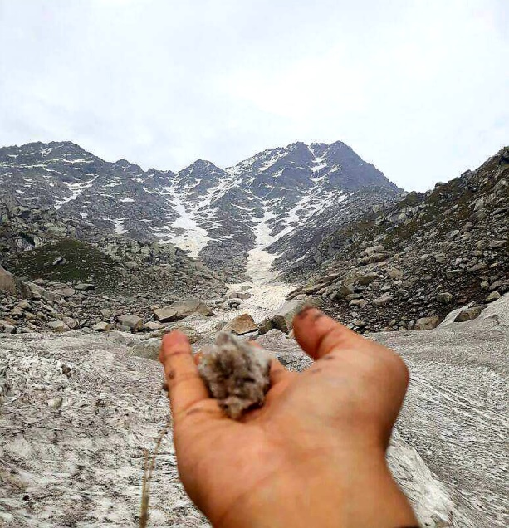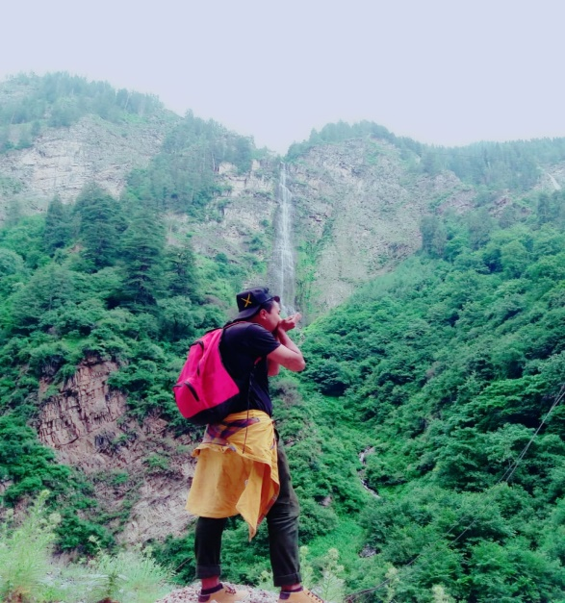
During evening we will check-in at ETU’s very own homestay set amidst picturesque location. The homestay surrounded by jungle and close to Hamachi village will provide you authentic Himachal experience. Here we will organize several fun games, both indoor and outdoor, as well as cook some delicious meal in most primitive way! Yes, we will use wood as fuel and stove made up of clay. And yes, not to forget the clay utensils which adds distinct flavor to the food!
Also arrangements will be made for bonfire, delicious BBQ, and yes some music by our in-house artists.

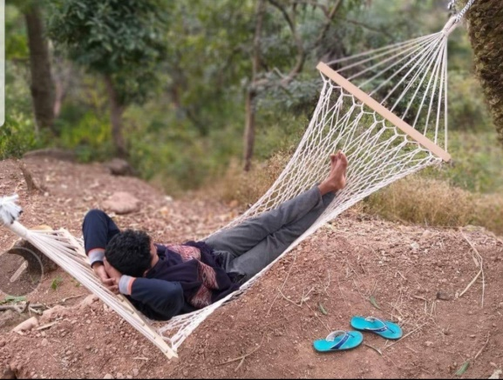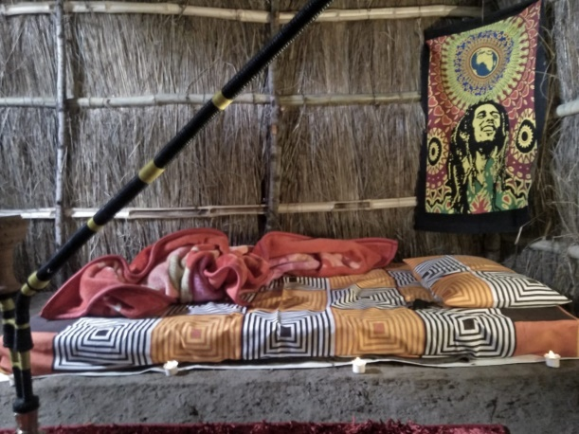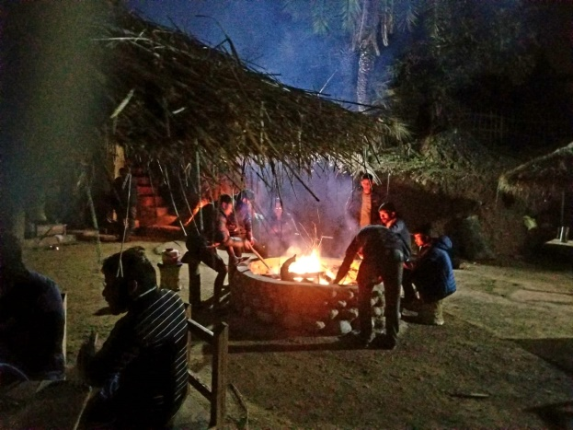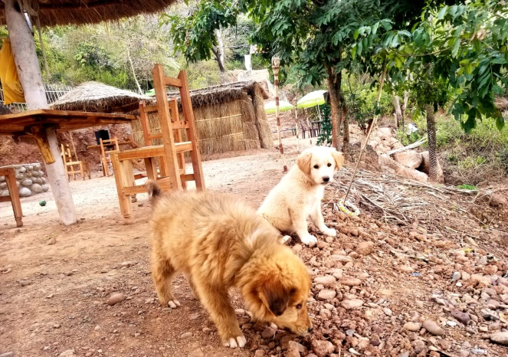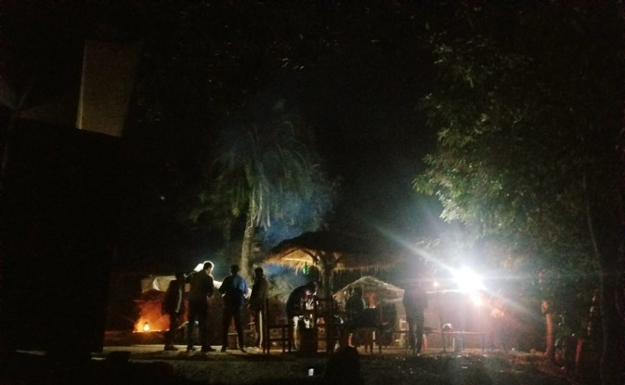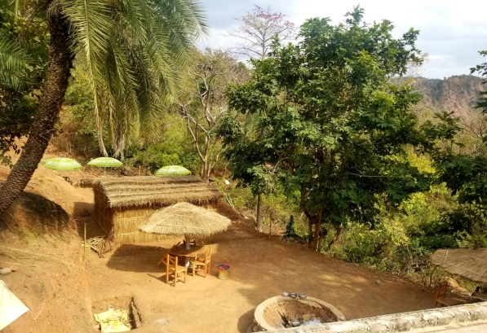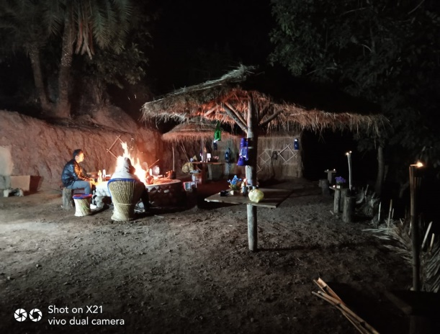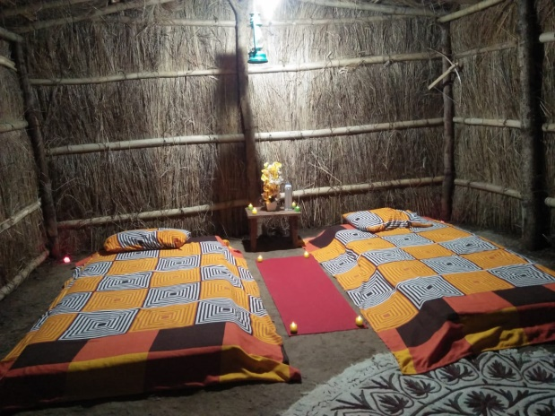
Day 3
The Riverside Himachal
Have you ever experienced full body mud pack? If not, you can definitely try it on this day. It’s not just refreshing but is also known to have certain therapeutic properties.
Also, have you ever swam in river’s safe spots and what about fishing, as well as cooking the fish you caught by the river side? If you haven’t done these, then the best time to do them is NOW..! We promise these experiences will truly provide a Wow experience.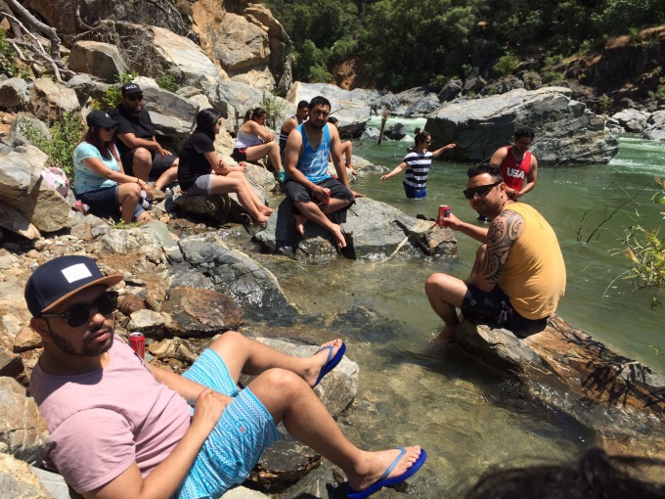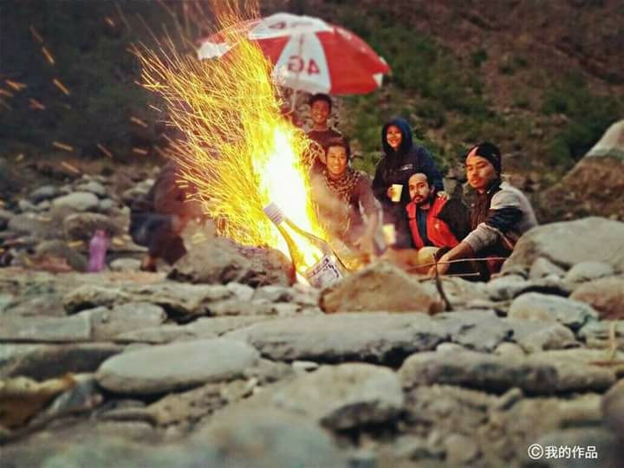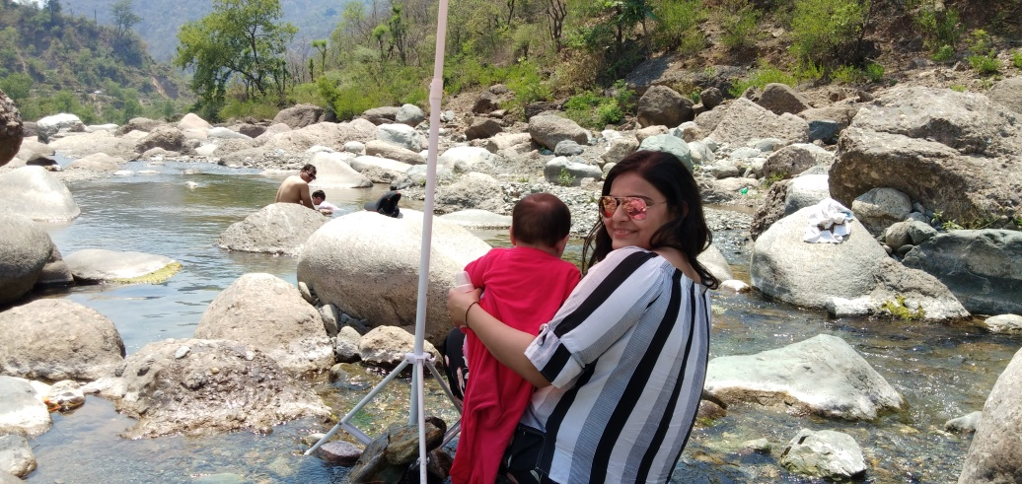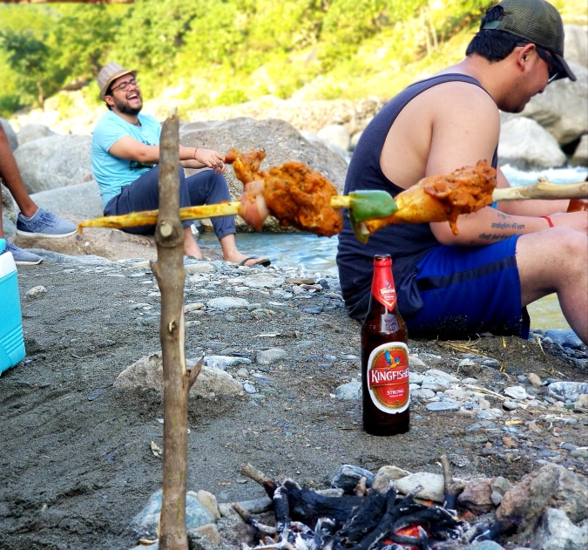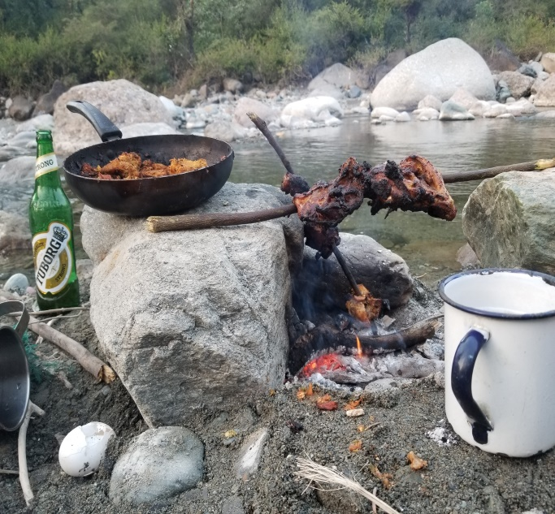
The Riverside Himachal is planned to include many unconventional activities like Meditation near the calmly flowing river, relaxing in the floating beds, calm rafting, and bathing in fresh water while our in-house cook prepares lip smacking delicacies!
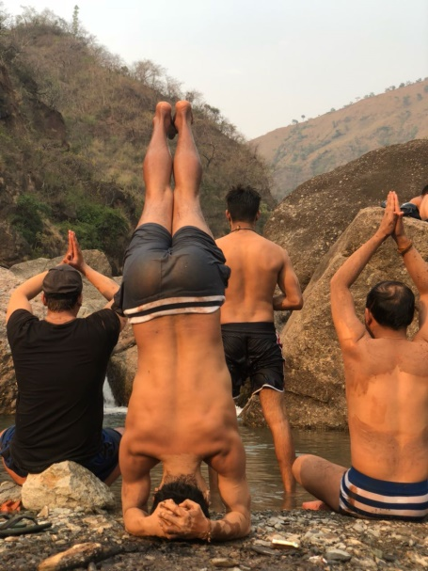
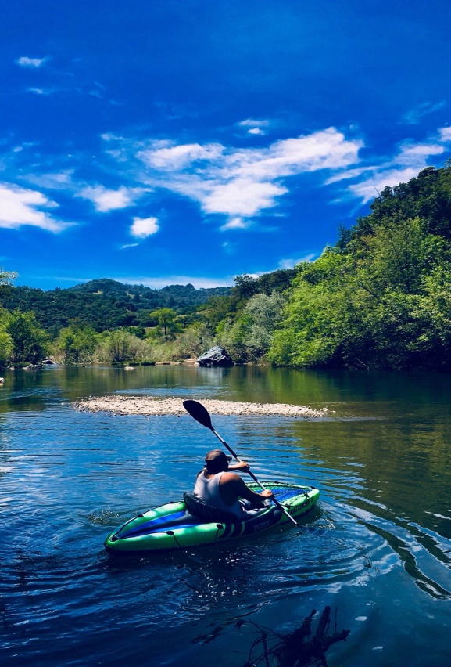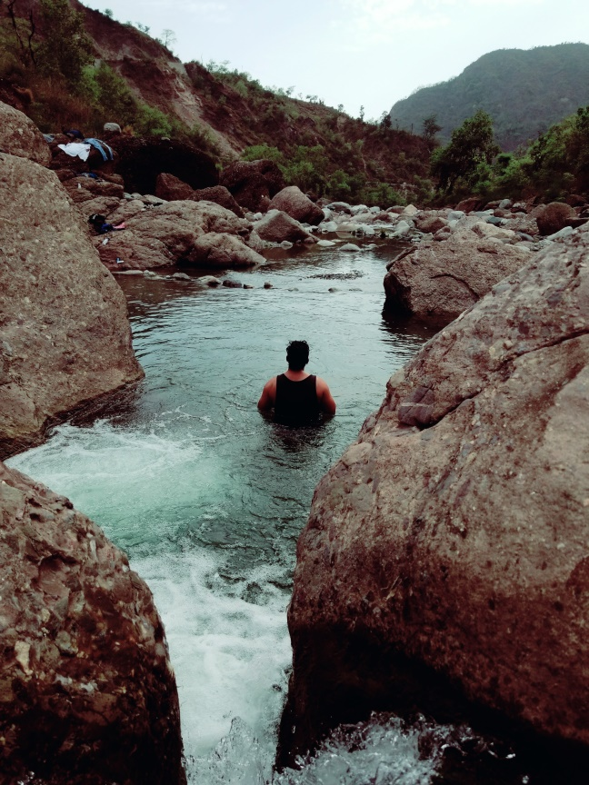

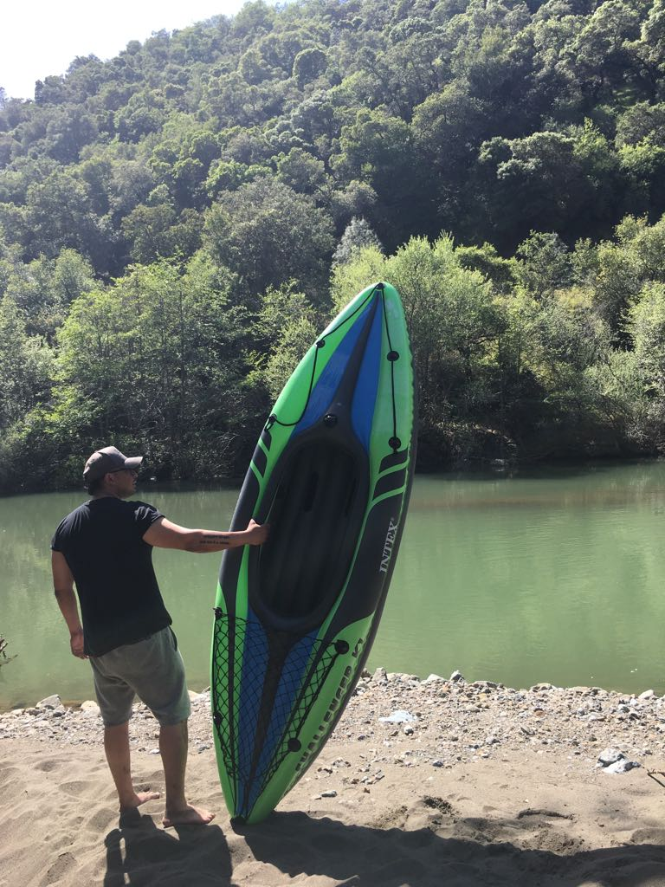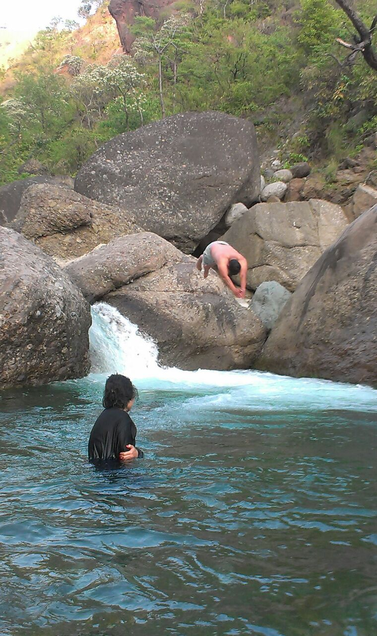

Note
Let us know your requirement and we will provide you a Customized Experience that suits your needs.
Contact Us
Website – www.ETUadventures.com
Email – admin@etuadventures.com
Phone – 9354712613/9882121616

Package Cost Includes:

- Pickup from the nearest Airport/Bus Stand/Railway Station.
- Cold drink, Water bottles and Snacks. 24*7 availability.
- Portable Kitchen for Tea and Snacks. 24*7 availability.
- Food Plan.
Physical Level: While the tour itself is not very strenuous, please note that it can involve the following: somewhat long days, a good amount of walking, early morning wake-ups and other similarly challenging scenarios.

Subject to Change: Please keep in mind that the above itinerary and activities are subject to change. Travel sometimes involves unexpected situations so things might need to be re-arranged at times. However, it is important to remember that travel is all about the journey, and so even the unexpected situations we may face should be treated as part of the overall experience!

Accommodations: Prices are based on the sharing of rooms and single members of the group will typically be put together. While we do our best to secure as many rooms with separate beds as possible, sometimes two members of the group might have to share a large bed but that’s all part of the adventure and we guarantee we’ll have a blast anyway.

Pick Up and Drop off: Please note there are no individual pick up and drops. Your Airport/Railway station/Bus station transfers will be clubbed with other roamers travelling with you on this trip. This might result in some wait at the Airport/Railway station/Bus station while pickup and an early drop at the Airport/Railway station/Bus station while leaving. If you want an individual pickup, let us know and we will arrange a private taxi for you. Price for that will be on the actual basis and you can pay the amount directly to the driver.

Terms and conditions:
We will not be liable for any claims or expenses arising from circumstances beyond our control such as accidents, injuries, delayed or cancelled flights & acts or forces of nature. The participants will have to bear the charges of cancellation (if charged by the hotel & other suppliers) arising due to delayed or cancelled flights/trains & acts or forces of nature.

Cancellation policy:
- 75% of your booking amount will be refunded if you cancel your participation before 45 days of the tour date.
- 50% of your booking amount will be refunded if you cancel your participation before 30 days of the tour date.
- 25% of your booking amount will be refunded if you cancel your participation before 15 days of the tour date.
No refund afterwards.

Package Cost does not Include:
- Air ticket, train ticket, bus ticket or any other transportation fare.
- Entrance fees, Camera fees, Guide fees or any other fee levied by authority.
- Personal expenses including shopping, tipping, charges for availing additional facility at the hotel/cottage like laundry.
- Meals and drinks pricing apart from the ones mentioned above.
- Insurance charges, evacuation in case of mishaps.
- Pricing for additional activities like horse riding, complete list mentioned below.

Activities (To be paid separately, activity rates/pricing not part of package pricing)
- Hiking
- Camping
- Horse Riding
- Zorbing
- Paragliding
- Yoga
- Meditation
- Swimming
- Cycling

About this Package:
- On all 3 days there will be different Terrain Sightseeing which will include Mountains, River, Forest, Jungle and Waterfall.
- 24*7 Customer Support.
- Cottages and Hotels used during this trip will offer you a beautiful and memorable experience. They are located on different terrains. Being away from city you will be able to experience pristine nature perfectly.

We welcome you to Himachal Pradesh, the land of Himalayas, adventure and pristine nature!

